Sales Analytics Platform

Objective:
Build a governed, multi-environment Sales analytics platform on Microsoft Fabric. This covers ingestion, transformation, modelling, orchestration, and reporting, deployed through Dev, Test, and Prod using Azure DevOps CI/CD.
Architecture
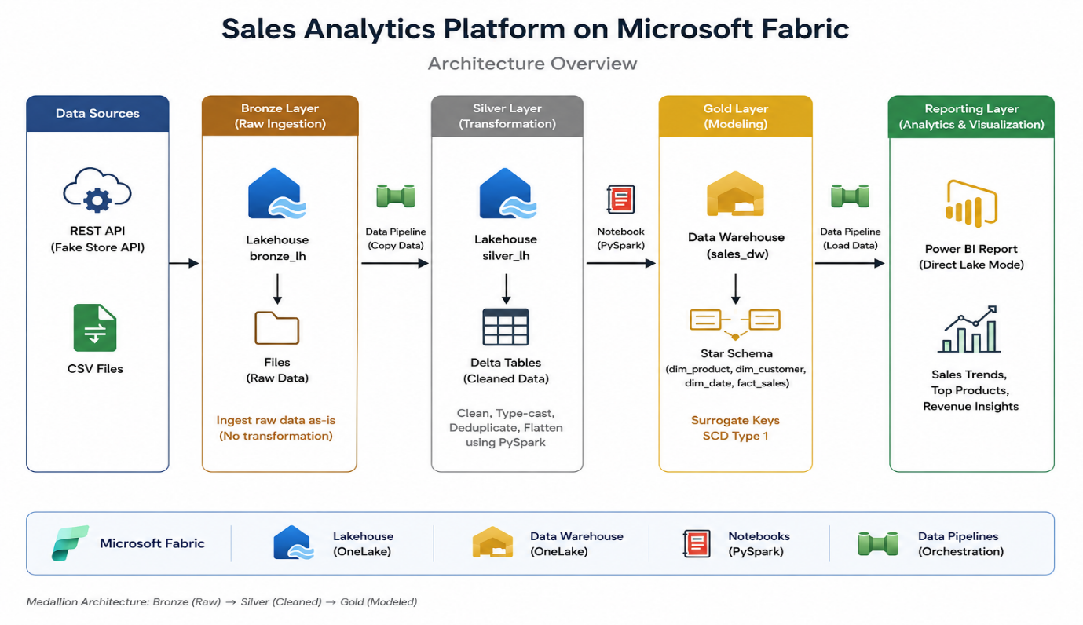
The Sales Analytics Platform is a Microsoft Fabric-based data analytics solution designed to collect, process, transform, model, and visualize sales data in a reliable and automated way.
The project follows a Medallion Architecture consisting of Bronze, Silver, and Gold layers. Raw sales data is first ingested into the Bronze layer without modification. The Silver layer cleans, transforms, type-casts, deduplicates, and structures the data using PySpark. The Gold layer contains business-ready dimension and fact tables following a Star Schema.
Microsoft Fabric Lakehouse is used for data storage and processing, while Power BI is used to create interactive sales reports. Azure DevOps Git provides version control, and the fabric-cicd library is used to automate deployment across Development, Test, and Production environments.
The complete solution is designed to support daily data processing, automated orchestration, reporting, version control, and controlled CI/CD deployments, helping deliver consistent and governed sales analytics across environments.

Phase 1: Prerequisites – Prepare Accounts and Permissions
The purpose of Phase 1 is to prepare the Microsoft Fabric and Azure DevOps environments, authentication, and permissions required for the Sales Analytics Platform and its CI/CD deployment.
1. Provision Microsoft Fabric
A Microsoft Fabric environment was prepared for the project.
Microsoft Fabric is used as the main data platform for:
- Lakehouse
- Data storage
- PySpark notebooks
- Data Pipelines
- Semantic Model
- Power BI reporting
The Fabric workspace is used to develop and manage the Sales Analytics Platform.
2. Create Azure DevOps Organization and Project
An Azure DevOps organization and project were created for the project.
Azure DevOps is used for:
- Git repository
- Branch management
- Pull Requests
- YAML pipelines
- CI/CD deployment
- Test and Production approval gates
The branch structure used in the project is:
dev
test
main
The dev branch is connected to the Development Fabric workspace.
3. Create Service Principal (SPN)
A Service Principal was created in Microsoft Entra ID for automated CI/CD deployment.
The Service Principal allows the Azure DevOps pipeline to authenticate with Microsoft Fabric without using a personal user account.
The important credentials are:
Tenant ID
Client ID
Client Secret
The Client ID and Client Secret were stored securely in Azure DevOps variables/variable groups rather than directly writing them into the Python script or YAML file.
Example:
AZURE_TENANT_ID
AZURE_CLIENT_ID
AZURE_CLIENT_SECRET
4. Enable Fabric API Access for Service Principal
The required Fabric Admin Portal setting was enabled:
Service principals can use Fabric APIs
This allows the Service Principal used by the CI/CD pipeline to interact with Microsoft Fabric resources.
5. Give SPN Access to Test and Production
The Service Principal was also given the required permissions on the target Fabric workspaces:
Service Principal
│
├── Test Workspace
│
└── Production Workspace
This is necessary because the CI/CD pipeline needs permission to deploy Fabric items into these workspaces.

Phase 2: Bronze Layer – Ingest Raw Data
The purpose of the Bronze Layer is to collect and store the source data in its original/raw form. No business transformations or data cleaning are performed at this stage.
1. Create the Development Workspace
A Microsoft Fabric workspace named:
sales-analytics-dev
was created for the development environment.
This workspace is used to develop the complete Sales Analytics Platform before promoting the solution to Test and Production.
2. Create the Bronze Lakehouse
Inside the development workspace, a Lakehouse named:
bronze_lh
was created.
The Bronze Lakehouse is the raw/landing layer of the Medallion Architecture.
Source Data
↓
bronze_lh
↓
Raw Data
The purpose of this layer is to preserve the source data so that it can be processed later in the Silver layer.
3. Ingest Sales Data
Sales data was collected from the required source systems:
- Sales REST API
- CSV files
A Fabric Data Pipeline was created to perform the ingestion.
The pipeline copies the source data into the Files section of the bronze_lh Lakehouse.
Sales REST API ──────┐
│
CSV Files ───────────┤
↓
Data Pipeline
↓
bronze_lh
/Files
4. Store Data Without Transformation
The Bronze layer keeps the incoming data untransformed.
For example, if the source CSV contains:
SalesID,Product,Quantity,Price,Customer,SaleDate
1,Laptop,2,750,John,2026-08-10
2,Mouse,5,25,David,2026-08-10
the Bronze layer stores the data as received.
5. File Organization
The incoming files were stored under the Lakehouse Files area using the required sales-data structure.
Example:
bronze_lh
└── Files
└── sales_data
└── 2026
└── 08
└── 11
└── sales_20260811_145815.csv
The file naming pattern used is:
sales_YYYYMMDD_HHMMSS.csv
This helps identify when each sales file was received.
6. Bronze Layer Result
After Phase 2, the raw sales data is available in the Bronze Lakehouse and is ready for transformation.

Phase 3: Silver Layer – Clean and Structure Data
The purpose of the Silver Layer is to clean and structure the raw data from the Bronze Layer.
1. Create the Silver Lakehouse
A new Lakehouse named:
s‍ilver_lh
was created to store the cleaned data.
2. Create a Notebook
A Notebook was created and attached to the bronze_lh Lakehouse.
The Notebook uses PySpark to read the raw Bronze data.
3. Clean the Data
The raw data was cleaned by:
- Handling null values
- Fixing data types
- Removing duplicate records
- Flattening and structuring the data
4. Store Cleaned Data
After transformation, the cleaned data was written as Delta tables into the silver_lh Lakehouse.
5. Silver Layer Result
The raw Bronze data is now clean, structured, and ready for the Gold Layer.

Phase 4: Gold Layer – Build the Star Schema
The purpose of the Gold Layer is to create business-ready tables for reporting and analysis.
1. Create the Gold Tables
The following tables were created:
- dim_product
- dim_customer
- dim_date
- fact_sales
These tables form the Star Schema.
2. Create Dimension Tables
The dimension tables store information about:
- Product – product details
- Customer – customer details
- Date – date information
Surrogate keys were applied to the dimension tables.
3. Create Fact Table
The fact_sales table stores the sales transaction data, such as:
- Quantity
- Unit price
- Revenue
- Discount
- Shipping
- Customer
- Product
- Date
The fact table is connected to the dimension tables using their keys.
4. Apply SCD Type 1
SCD Type 1 logic was applied to the Customer dimension.
When existing customer information changes, the old value is updated with the new value.
New customers are inserted into the table.
5. Load Data from Silver
Data was taken from the silver_lh tables and loaded into the Gold tables using SQL/upsert (MERGE) logic and notebooks.

Star Schema

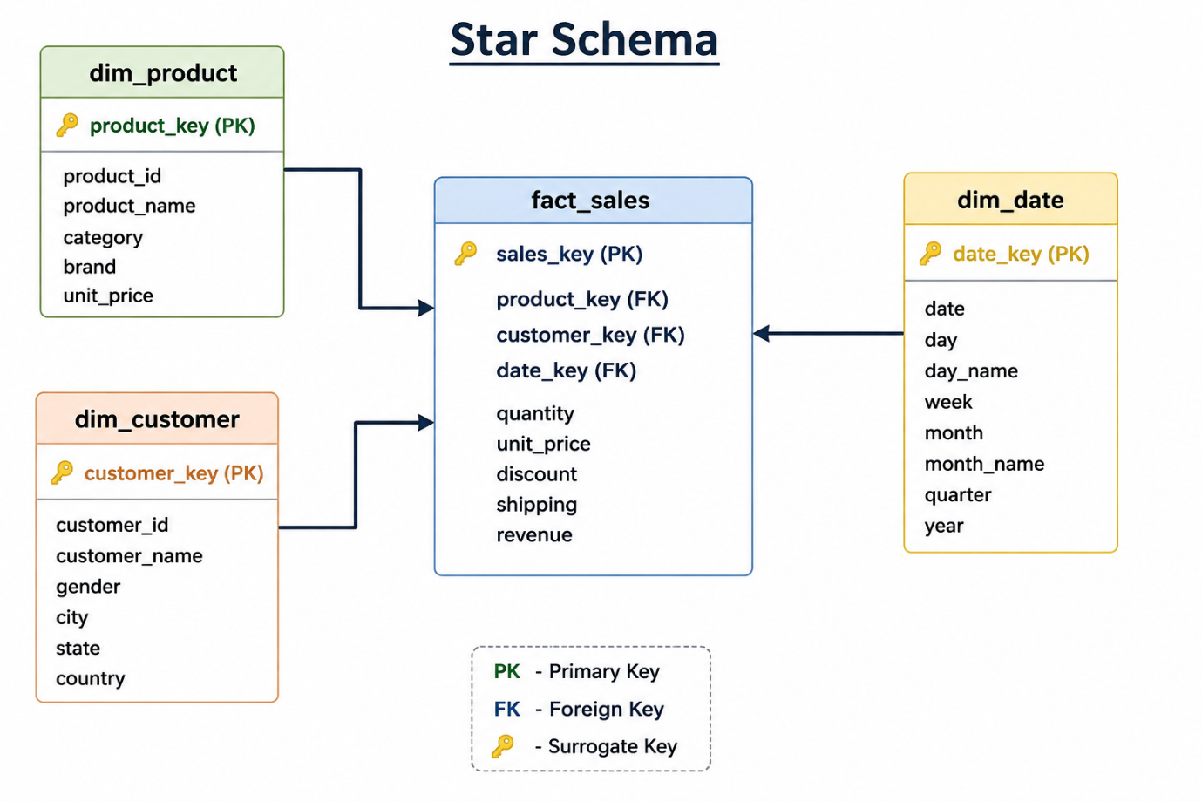
Phase 5: Orchestration – Automate the Workflow
The purpose of this phase is to automate the complete data flow from Bronze to Silver to Gold.
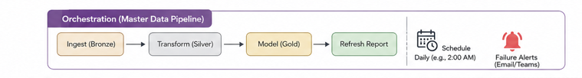
1. Create Master Data Pipeline
A master Data Pipeline was created to execute all the data processing steps in the correct order.
Bronze
↓
Silver
↓
Gold
2. Run Bronze Step
The pipeline first runs the Bronze ingestion process to collect the latest raw sales data.
3. Run Silver Step
After Bronze completes successfully, the pipeline runs the Silver Notebook to clean and transform the data.
4. Run Gold Step
After Silver completes successfully, the pipeline loads the transformed data into the Gold tables:
- dim_product
- dim_customer
- dim_date
- fact_sales
5. Schedule the Pipeline
The master pipeline was configured with a daily schedule, for example:
Every day at 2:00 pm
This allows the sales data to be processed automatically without manually running the pipeline.
6. Failure Alerts
Failure notifications were configured so that if any Bronze, Silver, or Gold step fails, the failure can be identified and addressed.

Phase 6: Reporting – Deliver Business Value
The purpose of this phase is to create a Power BI report using the Gold Layer data and provide useful sales insights.
1. Create Power BI Report
A New Power BI Report was created directly from the Gold data using Direct Lake mode.
The report is connected to the Gold tables:
- fact_sales
- dim_product
- dim_customer
- dim_date
2. Create Measures
Measures were created in the semantic model to calculate important business metrics such as:
- Total Revenue
- Total Sales
- Total Quantity
- Total Orders
- Total Customers
- Total Products
- Average Order Value
- Total Discount
- Total Shipping
- Total Tax
3. Create Report Visuals
The report contains visuals to analyze:
- Sales trends over time
- Revenue by month
- Top products by revenue
- Revenue by order status
- Sales/quantity by customer
4. Single Report Page
A single-page dashboard/report was created so that the main sales information can be viewed in one place.
5. Publish the Report
The Power BI report and its semantic model were published to the development workspace.
Gold Layer
↓
Semantic Model
↓
Power BI Report
↓
Sales Analytics Dashboard

6. Daily Data Updates
When the Bronze → Silver → Gold pipeline runs and new data is loaded into the Gold Layer, the Power BI report can reflect the updated data through the semantic model's Direct Lake connection.

Phase 7: Git Integration – Enable Version Control
The purpose of this phase is to connect Microsoft Fabric with Azure DevOps Git and maintain version control of the project.
1. Connect Dev Workspace to Azure DevOps
The Development workspace was connected to the Azure DevOps repository through Workspace Settings.
The workspace was connected to the dev branch.
2. Commit Workspace Items
The Fabric workspace items were committed to the dev branch.
The committed items include:
- Lakehouse
- Notebooks
- Data Pipelines
- Semantic Model
- Power BI Report
These items are now available in the Azure DevOps repository.
3. Create Branches
Additional branches were created for the deployment process:
- dev – Development
- test – Testing/Staging
- main – Production
Phase 8: CI/CD Pipeline – Automate Deployments Across Environments
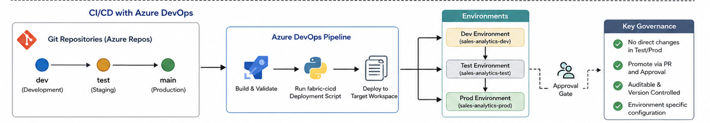
The purpose of this phase is to automate the deployment of Fabric items from the Git repository to the Test and Production environments using Azure DevOps.
1. Create parameter.yml
A parameter.yml file was created to store the environment-specific workspace IDs.
It contains:
Test Workspace ID
Prod Workspace ID
The Dev workspace ID is not required because the development workspace is connected to the Git branch used for development.
2. Create Azure DevOps YAML Pipeline
An Azure DevOps YAML pipeline was created to run the Python deployment script.
The pipeline:
- Gets the code from the repository.
- Installs Python.
- Installs fabric-cicd and azure-identity.
- Reads the environment configuration.
- Runs the Python deployment script.
- Deploys the Fabric items to the target workspace.
3. Configure Test and Prod Environments
Two Azure DevOps environments were created:
- Test → connected to the Test workspace deployment.
- Prod → connected to the Production workspace deployment.
4. Manual Approval Gates
Manual approval gates were configured for the Test and Prod environments.
The pipeline pauses and waits for approval before continuing with the deployment.
feature/test
↓
dev
↓
CI/CD Pipeline
↓
Test Approval
↓
Test Workspace
↓
Prod Approval
↓
Prod Workspace

Phase 9: Full Loop Validation – Test the Automation
The purpose of this phase is to test the complete Git and CI/CD deployment process from Development to Test and Production.
1. Make a Change in Dev
A small change was made in the Dev workspace.
The change was committed to the Git branch.
Dev Workspace
↓
Commit
↓
dev branch
2. Create Pull Request to Test
A Pull Request was created from the development branch to the Test branch.
dev
↓
PR
↓
test
After the Pull Request was approved and merged, the Azure DevOps CI/CD pipeline was triggered.
3. Deploy to Test
The pipeline started the Test deployment.
The configured Test approval gate paused the pipeline and waited for manual approval.
After approval:
Test Approval
↓
Test Workspace
The changes were then deployed to the Test workspace.
4. Verify Test Workspace
The Test workspace was checked to confirm that the changes from Dev were successfully deployed.
5. Deploy to Production
After successful Test validation, the changes were promoted toward Production.
Test
↓
PR
↓
main
↓
Prod Approval
↓
Prod Workspace
The Prod approval gate was used before the Production deployment.
After approval, the pipeline deployed the changes to the Production workspace.
6. Verify Production
The Production workspace was checked to confirm that the same changes were successfully deployed.
